
As someone who knows about business documentation, you are asked to use the blank documents provided on the following pages to complete the following three tasks, which relate to an order placed by Bookworms, a small independent book shop, to the publisher Paige Turner Ltd.
NAME:
Bookworms (Solution)
TASK 1
The owner of Bookworms asks if you can complete a purchase order for them. They’d like to order the following items from Paige Turner Books Ltd, who have the supplier reference of PTurner, and are located at 1 Road, Somewhere Inn, England, NE1 0NO:
- 10 copies of item 3256: “Business Made Easy” at a price of £10.99 each
- 20 copies of item 9852: “Business 4U” at a price of £4.50 each
- 15 copies of item 2216: “How to Make Your Millions” at a price of £8.99 each
The items should be delivered to Bookworms (address provided on the purchase order), and the purchase order number is 17854. The order should be dated today, with the items required within 7 days time. Books are “zero-rated” for VAT purposes.
TASK 2
Now complete the invoice that Paige Turner Books Ltd woud send to Bookworms in relation to the purchase order you completed in Task 1. The invoice number will be 765298, and Paige Turner Books Ltd expect customers to pay within 30 days.
TASK 3
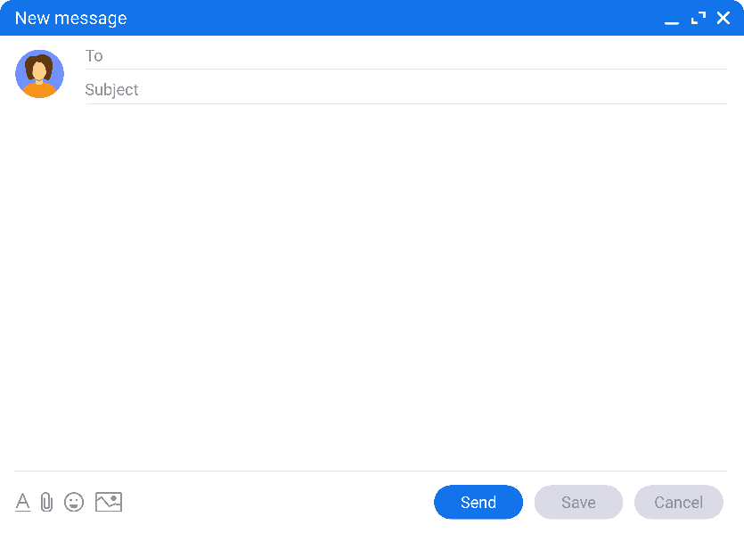
Paige Turner Books Ltd have received the email shown from Bookworms.
Thank you for the recent delivery of books in relation to PO Number 17854.
Unfortunately, there appears to be a printing error in the Business 4U books, as the first 20 pages are blank.
Could you please provide credit for these items?
Many thanks
Faulty Books
finance@paigeturner.org
Refund Bookworms for the faulty books by completing a credit note, with the credit note number UR132, dated 7 days later than the invoice you completed in Task 2.


12 Reading Street
Nearhere
Bookworms
England
UR1 2US

SOLUTION
Purchase Order
DATE |  | 15/10/2022 |  | REQUIRED BY: |  | 22/10/2022
P.O. NUMBER: |  | 17854 |  | SUPPLIER REF: |  | PTurner
SUPPLIER |  |  |  | DELIVER TO:
Paige Turner Books Ltd  1 Road  Somewhere Inn  England  NE1 0NO |  |  |  | Bookworms  12 Reading Street  Nearhere  England  UR1 2US
Please Supply:
QUANTITY | DESCRIPTION |  |  |  | ITEM CODE | UNIT PRICE (£)
10 | Business Made Easy |  |  |  | 3256 | 10.99
20 | Business 4U |  |  |  | 9852 | 4.50
15 | How to Make Your Millions |  |  |  | 2216 | 8.99
Special Instructions:
Ordered By:
Authorised By:
Suppliers should note that only authorised orders are valid
Note date should be today’s date, with required by date being 7 days later


SOLUTION
INVOICE
DATE: |  | 17/10/2022 |  | P.O. NUMBER: |  | 17854
INVOICE NUMBER: |  | 765298 |  | TERMS: |  | 30 days
INVOICE TO |  |  |  | DELIVER TO
Bookworms |  |  |  | Bookworms
12 Reading Street |  |  |  | 12 Reading Street
Nearhere |  |  |  | Nearhere
England |  |  |  | England
UR1 2US |  |  |  | UR1 2US
ITEM NO. | DESCRIPTION |  |  | QTY | UNIT PRICE | TOTAL
3256 | Business Made Easy |  |  | 10 | £ 10.99 | £ 109.90
9852 | Business 4U |  |  | 20 | £ 4.50 | £ 90.00
2216 | How to Make Your Millions |  |  | 15 | £ 8.99 | £ 134.85
Additional Comments: |  |  |  | SUBTOTAL: |  | £ 334.75
 |  |  |  | VAT @ | 0.00% | £ 0.00
 |  |  |  | DELIVERY: |  | £ 0.00
 |  |  |  | TOTAL: |  | £ 334.75
Cheques should be made payable to Paige Turner Books Ltd.
For BACS payments use:
Account name: P Turner
Sort Code: 98-76-54
Account Number: 45463721
T&Cs Apply, E&OE
THANK YOU
Paige Turner Books Ltd, 1 Road, Somewhere Inn, England, NE1 0NO
Email: finance@paigeturner.org Tel: 09876 12345
Note date should be between today’s date, and required by date (7 days later)

SOLUTION
Credit Note
DATE |  | 24/10/2022 |  | CREDIT NOTE NUMBER: |  | UR132
P.O. NUMBER: |  | 17854 |  | CUSTOMER ACCOUNT: |  | Bookworms
CUSTOMER |  |  |  | REASON FOR CREDIT
Bookworms  12 Reading Street  Nearhere  England  UR1 2US |  |  |  | Printing error
ITEM NO. | DESCRIPTION |  |  | QTY | UNIT PRICE | TOTAL
9852 | Business 4U |  |  | 20 | £ 4.50 | £ 90.00
 |  |  |  | SUBTOTAL: |  | £ 90.00
 |  |  |  | VAT @ | 0.00% | £ 0.00
 |  |  |  | TOTAL CREDIT: |  | £ 90.00

Note date should be 7 days after the date used on the invoice

Paige Turner Books Ltd, 1 Road, Somewhere Inn, England, NE1 0NO
Email: finance@paigeturner.org Tel: 09876 12345

