
As someone who knows about business documentation, you are asked to use the blank documents provided on the following pages to complete the following three tasks, which relate to an order placed by Bookworms, a small independent book shop, to the publisher Paige Turner Ltd.
NAME:
Bookworms
TASK 1
The owner of Bookworms asks if you can complete a purchase order for them. They’d like to order the following items from Paige Turner Books Ltd, who have the supplier reference of PTurner, and are located at 1 Road, Somewhere Inn, England, NE1 0NO:
- 10 copies of item 3256: “Business Made Easy” at a price of £10.99 each
- 20 copies of item 9852: “Business 4U” at a price of £4.50 each
- 15 copies of item 2216: “How to Make Your Millions” at a price of £8.99 each
The items should be delivered to Bookworms (address provided on the purchase order), and the purchase order number is 17854. The order should be dated today, with the items required within 7 days time. Books are “zero-rated” for VAT purposes.
TASK 2
Now complete the invoice that Paige Turner Books Ltd woud send to Bookworms in relation to the purchase order you completed in Task 1. The invoice number will be 765298, and Paige Turner Books Ltd expect customers to pay within 30 days.
TASK 3
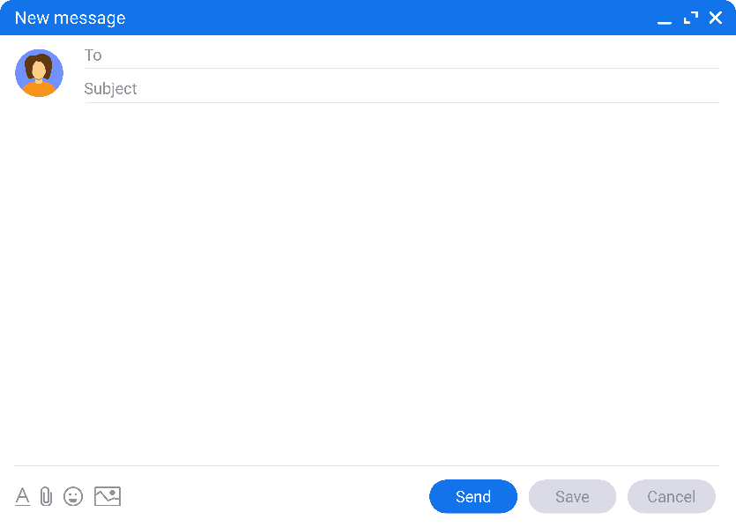
Paige Turner Books Ltd have received the email shown from Bookworms.
Thank you for the recent delivery of books in relation to PO Number 17854.
Unfortunately, there appears to be a printing error in the Business 4U books, as the first 20 pages are blank.
Could you please provide credit for these items?
Many thanks
Faulty Books
finance@paigeturner.org
Refund Bookworms for the faulty books by completing a credit note, with the credit note number UR132, dated 7 days later than the invoice you completed in Task 2.


12 Reading Street
Nearhere
Bookworms
England
UR1 2US

Purchase Order
DATE |  |  |  | REQUIRED BY:
P.O. NUMBER: |  |  |  | SUPPLIER REF:
SUPPLIER |  |  |  | DELIVER TO:
Please Supply:
QUANTITY | DESCRIPTION |  |  |  | ITEM CODE | UNIT PRICE (£)
Special Instructions:
Ordered By:
Authorised By:
Suppliers should note that only authorised orders are valid



INVOICE
DATE: |  |  |  | P.O. NUMBER:
INVOICE NUMBER: |  |  |  | TERMS:
INVOICE TO |  |  |  | DELIVER TO
ITEM NO. | DESCRIPTION |  |  | QTY | UNIT PRICE | TOTAL
Additional Comments: |  |  |  | SUBTOTAL: |  | £
 |  |  |  | VAT @ | 0.00% | £
 |  |  |  | DELIVERY: |  | £
 |  |  |  | TOTAL: |  | £
Cheques should be made payable to Paige Turner Books Ltd.
For BACS payments use:
Account name: P Turner
Sort Code: 98-76-54
Account Number: 45463721
T&Cs Apply, E&OE
THANK YOU

Paige Turner Books Ltd, 1 Road, Somewhere Inn, England, NE1 0NO
Email: finance@paigeturner.org Tel: 09876 12345

CREDIT NOTE
DATE |  |  |  | CREDIT NOTE NUMBER:
P.O. NUMBER: |  |  |  | CUSTOMER ACCOUNT:
CUSTOMER |  |  |  | REASON FOR CREDIT
ITEM NO. | DESCRIPTION |  |  | QTY | UNIT PRICE | TOTAL
 |  |  |  | SUBTOTAL: |  | £
 |  |  |  | VAT @ | 0.00% | £
 |  |  |  | TOTAL CREDIT: |  | £

Paige Turner Books Ltd, 1 Road, Somewhere Inn, England, NE1 0NO
Email: finance@paigeturner.org Tel: 09876 12345

