Ann Youlee runs a business that prints calendars. She has provided details of transactions that took place in March (Task 1) and October (Task 2). For each month, complete the tables provided.
NAME:
Cash Calendar (Solution)
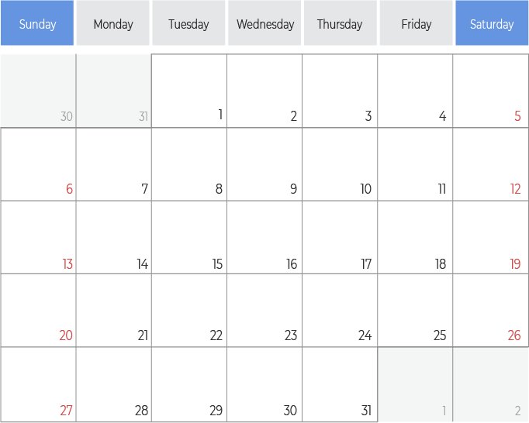
TASK 1 – MARCH
MARCH

£1,567 in the bank
Ordered Paper & paid £1,000

Received paper ordered on the 4th

Products sold for £3,000 to be received next month
Received £4,800 from sales made last month

Factory rent of £1,000 paid

£1,500 used to pay staff wages
£500 bill payable now for ink used this month

PROFIT FOR MACRH |  |  | CASH POSITION IN MARCH
Total Revenue = | £3,000 |  | Cash at start of month = | £1,567
Fixed Costs = | £1,000 |  | Cash received during month = | £4,800
Variable Costs = | £3,000 |  | Cash spent during month = | £4,000
Profit = | - £1,000 |  | Cash left at end of month = | £2,367

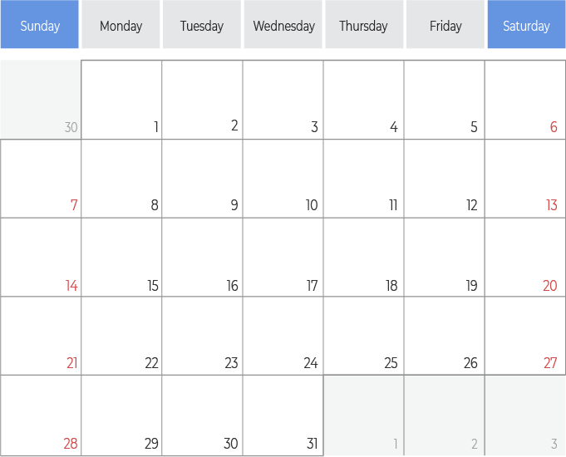
TASK 2 – OCTOBER
OCTOBER

Ordered Paper & paid £1,200
£4,723 in the bank
Received paper ordered on the 5th

Received £3,350 from sales made last month
Ordered Paper & paid £1,300

Products sold for £8,000 to be received next month
Received paper ordered on the 16th
Factory rent of £1,000 paid

£2,000 paid for ink used this month
£2,000 used to pay staff wages

PROFIT FOR OCTOBER |  |  | CASH POSITION IN OCTOBER
Total Revenue = | £8,000 |  | Cash at start of month = | £4,723
Fixed Costs = | £1,000 |  | Cash received during month = | £3,350
Variable Costs = | £6,500 |  | Cash spent during month = | £7,500
Profit = | £500 |  | Cash left at end of month = | £573

