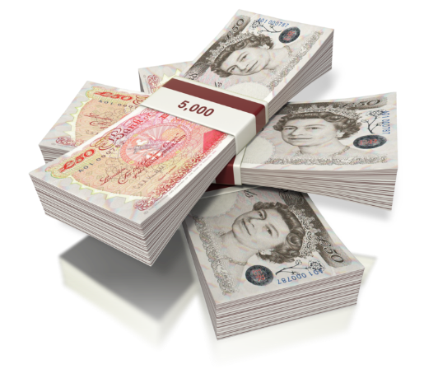
It’s important for a business to understand whether they are making a profit or a loss.
Profit or Loss? (Solution)
NAME:
TASK 1
For each of the scenarios provided below, identify whether the business would be making an overall profit or loss, and calculate the value of it.
 | SCENARIO | PROFIT OR  LOSS PER UNIT? | VALUE OF PROFIT/LOSS
1 | A business received total revenue of £879,000 from selling goods that it cost them a total of £690,000 to make. | PROFIT | £189,000
2 | A business sold 100 items at a price of £75. The total cost of making the 100 items was £7,800. | LOSS | -£300
3 | A business received £150,000 total revenue by selling goods that had cost £30,000 in fixed costs and £130,000 in total variable costs. | LOSS | -£10,000
4 | A business incurred fixed costs of £100,000 and total variable costs of £400,000. It sold 170,000 products at a price of £3.50 each. | PROFIT | £95,000
5 | A business sold 196 items at a price of £125. The total cost of making the 196 items was £25,000. | LOSS | -£500
6 | A business received £8,000 total revenue by selling goods that had cost £3,000 in total variable costs and £1,000 in fixed costs. | PROFIT | £4,000
7 | A business sold 25,000 items at a price of £1.99. The total cost of making the 25,000 items was £45,000. | PROFIT | £4,750
8 | A business sold 19,452 products at a price of £0.75 each. Their fixed costs were £4,726 and the variable cost per unit was £0.25. | PROFIT | £5,000
9 | A business sold 295,000 products at a price of £4.99 each. Their fixed costs were £472,100 and the variable cost per unit was £3.39. | LOSS | -£100
10 | A business incurred fixed costs of £379,489 and total variable costs of £1,289,375. It sold 149,500 products at a price of £9.99 each. | LOSS | £175,359

TASK 2
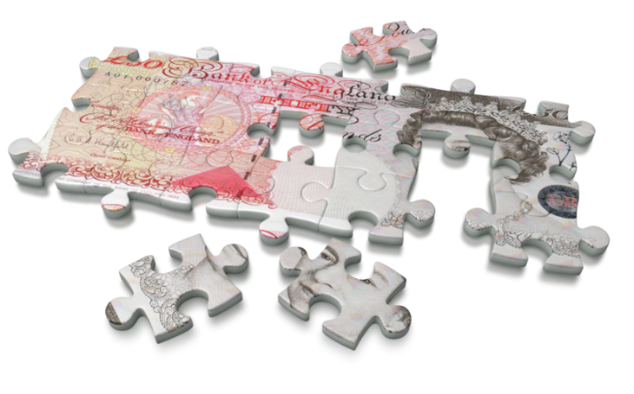
For each of the scenarios provided below, identify whether the business would be making a profit or loss per unit sold, and calculate the value of it.
 | SCENARIO | PROFIT OR  LOSS PER UNIT? | VALUE OF PROFIT/LOSS
1 | A business sells a product at a price of £2.50. The variable cost per unit is £1.30, whilst the fixed cost per unit is £1.00. | PROFIT | £0.20 per unit
2 | A business sold 5,000 items at a price of £4.99. The total cost of making them was £7,800. | PROFIT | £3.43 per unit
3 | A business receives £15,000 total revenue from selling 2,500 units of a product. The total cost per unit was £4.50. | PROFIT | £1.50 per unit
4 | A business pays fixed costs of £10,000. During the same period, it sells 20,000 units of a product at a price of £1.49 each. Each unit has a variable cost of £1.00. | LOSS | -£0.01 per unit
5 | A business sold 1,900 items at a price of £9.99. The total cost of making these items was £28,500. | LOSS | -£5.01 per unit
6 | A business sells 10,000 products at a price of £6.49. The total variable cost of making them is £30,000, with a fixed cost per unit of £1.49. | PROFIT | £2.00 per unit
7 | A business sold 125,000 items at a price of £0.99. The total cost of making the 125,000 items was £155,000. | PROFIT | £0.25 per unit
8 | A business sold 39,700 products at a price of £0.65 each. Their fixed costs were £15,880 and the variable cost per unit was £0.19. | PROFIT | £0.06 per unit
9 | A business has fixed costs of £98,380 and total variable costs of £201,620 when it produces 100,000 units that it sells for £4.00 each. | PROFIT | £1.00 per unit
10 | A business incurs variable costs per unit of £14.37 and total fixed costs of £25,000 when it produces 2,500 units. Total revenue of £50,000 is received by selling the 2,500 units. | LOSS | -£4.37 per unit

