You’ve been asked to provide some financial advice to local people who are setting up, or have recently set up, their own business. Each business owner has identified what their business needs to buy in the table below. However, they are not sure which source of capital would be the most appropriate for them to use.
Use the information provided to select the two sources of capital that you think would be most appropriate for each business. There may be more than two suitable sources, so you should justify your choices! Once you’ve done that, compare your answers with someone else to see whether you agree, and be prepared to explain your thinking.
Which Source of Capital?
NAME:
Business 1 – Ann Chovie | Recommended Sources  of Capital with Reason

Ann Chovie is opening a small local pizza takeaway and delivery business. She is looking to buy motorbikes for her delivery drivers that will last a few years. She has already had a grant from the local council, and is reluctant to ask friends and family for financial help.

Business 2 – Ivan Idea | Recommended Sources  of Capital
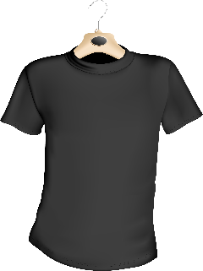
Ivan Idea runs a small business designing clothes. He has been developing a new material that he believes will mean that clothes can last a lifetime, but he needs money to continue developing the product, without risking the rest of his business.

Business 3 – Adam Upp | Recommended Sources  of Capital
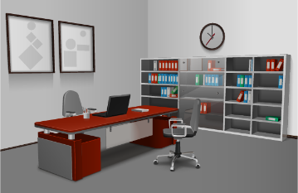
Adam Upp has recently qualified as an accountant, and wants to set up his own accountancy business. He has agreed to rent an empty office, however he now needs some suitable office furniture and equipment including computers, but doesn’t have enough of his own savings to buy what he needs.

Business 4 – Bill Derr | Recommended Sources  of Capital

Bill Derr is looking to set up a small construction business, and knows that there are customers waiting for a builder to do work such as extensions. He thinks a mini-digger would help him complete jobs faster, and fit more work in.

Business 4 – Flo Tinaway | Recommended Sources  of Capital

Flo Tinaway runs her own plumbing business. She would like to start supplying bathrooms as well as fitting them, so is setting up a showroom in the warehouse she already owns. However, Flo needs capital to pay for the baths, sinks and toilets that she will use in the displays.

