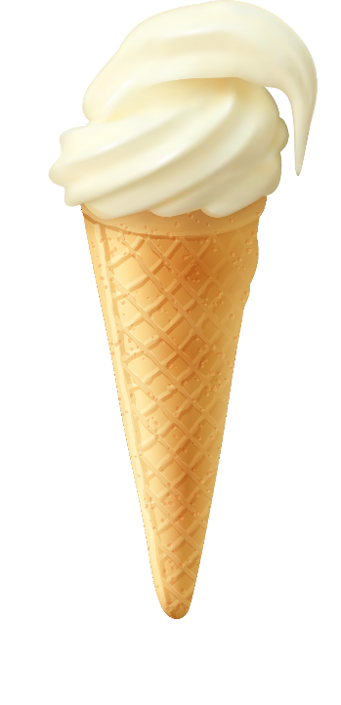
Marsha Mellow runs Igloo Ices, a sole trader business that sells ice cream. She currently owns one ice cream van, but dreams of eventually owning a chain of ice cream shops. Marsha finds the money-side of her business confusing, and feels that she needs to understand it better so asks for your help.
Marsha has provided some financial information from her business. You should use the information provided to answer her questions, providing explanations where required.
Task 1
The expected costs that Igloo Ices will incur next year are listed below. Identify which costs are fixed, and which costs are variable, explaining the difference between them.
Igloo Ices – Costs (Solution)
NAME:
Cost | Amount | Fixed or Variable?
Mr Whippy Soft Ice Mix (per cone) | £0.02 | Variable
Fuel (average per week) | £35.00 | Fixed
Ice Cream Cones (per cone) | £0.02 | Variable
Mobile Trading License(per year) | £550.00 | Fixed
Van insurance(per year) | £350.00 | Fixed
Public Liability Insurance(per year) | £180.00 | Fixed
Sauces/Toppings(average per cone) | £0.01 | Variable
Given this information, Marsha asks you to calculate the fixed and variable costs that Igloo Ices expect to incur. Record your answers below, showing your working:
 | Expected Fixed costs for the Year |  | Expected Variable costs per cone
Working Out | Fuel: £35 x 52 = | £1,820 | Mr Whippy Soft Ice Mix = |  | £0.02
Working Out | Mobile Trading License = | £550 | Ice cream cones = |  | £0.02
Working Out | Van Insurance = | £350 | Sauces/Toppings = |  | £0.01
Working Out | Public Liability Insurance = | £180
Total: |  | £2,900 |  | £0.05

Finally explain to Marsha what fixed costs and variable costs are:
Fixed costs are… | Costs that a business must pay irrespective how much is produced or sold. E.g. Marsha will have to pay van insurance, irrespective of how many cones she sells.
Variable costs are… | Costs that change in direct proportion to output. E.g. the more ice creams she sells, the more ice cream cones Marsha will need to buy.

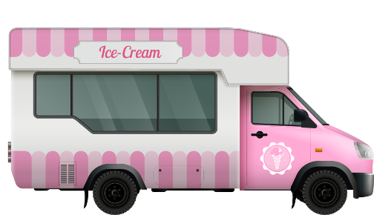
Task 2
Using the figures that you have just calculated, Marsha would now like you to calculate the total cost of making various quantities of ice cream next year by completing the table below to provide this information.
Start by writing down the formula for Total Cost:
Total Costs = | __________________  Fixed Costs | + | _____________________  Variable Costs

Use the information you now have to complete the table below:
Ice Creams Sold | 0 | 500 | 1,000 | 1,500 | 2,000 | 2,500 | 3,000
Fixed Costs (£) | 2,900 | 2,900 | 2,900 | 2,900 | 2,900 | 2,900 | 2,900
Variable Costs (£) | 0 | 25 | 50 | 75 | 100 | 125 | 150
Total Costs (£) | 2,900 | 2,925 | 2,950 | 2,975 | 3,000 | 3,025 | 3,050

