
Marsha Mellow runs Igloo Ices, a sole trader business that sells ice cream. She currently owns one ice cream van, but dreams of eventually owning a chain of ice cream shops. Marsha finds the money-side of her business confusing, and feels that she needs to understand it better so asks for your help.
Marsha has provided some financial information from her business. You should use the information provided to answer her questions, providing explanations where required.
Task 1
The expected costs that Igloo Ices will incur next year are listed below. Identify which costs are fixed, and which costs are variable, explaining the difference between them.
Igloo Ices – Costs
NAME:
Cost | Amount | Fixed or Variable?
Mr Whippy Soft Ice Mix (per cone) | £0.02
Fuel (average per week) | £35.00
Ice Cream Cones (per cone) | £0.02
Mobile Trading License (per year) | £550.00
Van insurance (per year) | £350.00
Public Liability Insurance (per year) | £180.00
Sauces/Toppings (average per cone) | £0.01
Given this information, Marsha asks you to calculate the fixed and variable costs that Igloo Ices expect to incur. Record your answers below, showing your working:
 | Expected Fixed costs for the Year |  | Expected Variable costs per cone
Working Out
Total:

Finally explain to Marsha what fixed costs and variable costs are:
Fixed costs are…
Variable costs are…

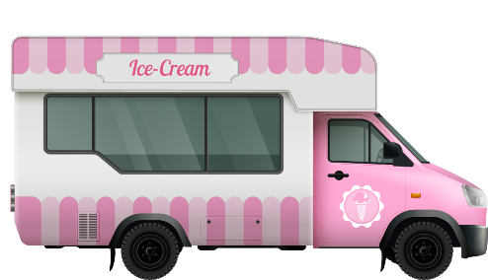
Task 2
Using the figures that you have just calculated, Marsha would now like you to calculate the total cost of making various quantities of ice cream next year by completing the table below to provide this information.
Start by writing down the formula for Total Cost:
Total Costs = | __________________ | + | _____________________

Use the information you now have to complete the table below:
Ice Creams Sold | 0 | 500 | 1,000 | 1,500 | 2,000 | 2,500 | 3,000
Fixed Costs (£)
Variable Costs (£)
Total Costs (£)

