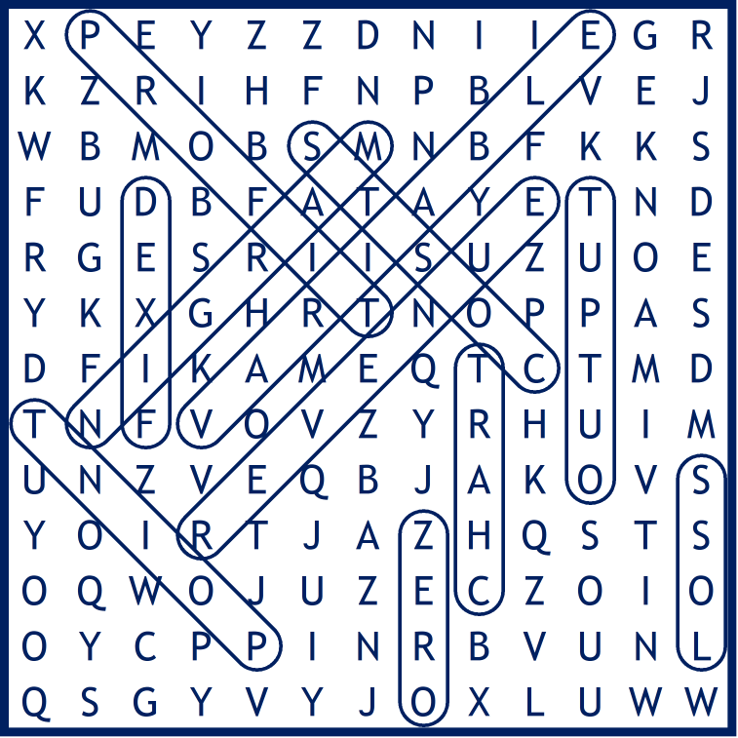
Break Even Word Search (Solution)
NAME:

- VARIABLE costs will increase as more is produced, but will be zero if nothing is produced
- A break-even CHART illustrates the break-even point graphically
- A business that doesn't reach their break-even point will make this LOSS
- A business that is able to make and sell more than the break-even level of output will make this PROFIT
- The MARGIN of safety is calculated by subtracting the break-even level of output from the actual output
- The break-even POINT occurs where total revenue and total costs are equal
- The goods that are produced OUTPUT
- The level of profit being made when a firm is breaking even ZERO
- These costs do not change in direct proportion to the amount produced FIXED
- Total COSTS will increase as more is produced, but will not be zero even if nothing is produced
- Total REVENUE is the money received from selling the goods that are produced

