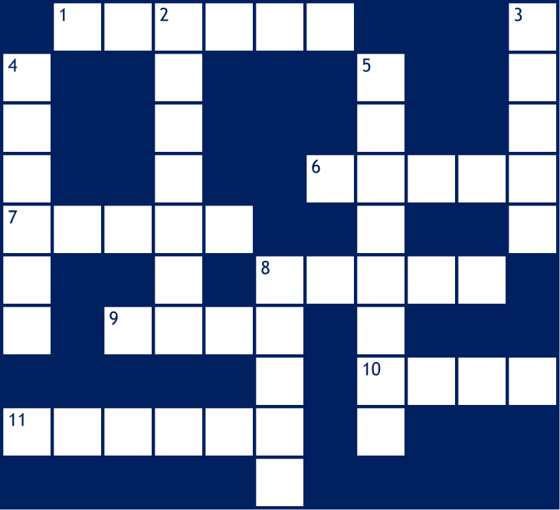
Complete the crossword below using the clues provided.
Break Even Crossword
NAME:

Across
1 The ______ of safety is calculated by subtracting the break-even level of output from the actual output (6)
6 The break-even point can be calculated using the formula: Fixed Costs/(Selling _____ - Variable costs) (5)
7 The break-even _____ occurs where total revenue and total costs are equal (5)
8 A break-even _____ illustrates the break-even point graphically (5)
9 The amount of profit being made by a business that is breaking-even (4)
10 This is made if a business is unable to make and sell enough to reach the break-even level (4)
11 This is made if a business is able to make and sell more than the break-even level (6)

Down
2 Total _______ is the money received from selling the goods that are produced (7)
3 These costs will not change in direct proportion to the amount produced (5)
4 The goods that are produced (6)
5 ________ costs will be zero when nothing is produced and increase as more is produced (8)
8 Total _____ will increase as more is produced, but will not be zero if nothing is produced (5)

An interactive version of this activity is available at https://www.businessed.co.uk/activities/crosswords/break-even/index.html

